Registration Form
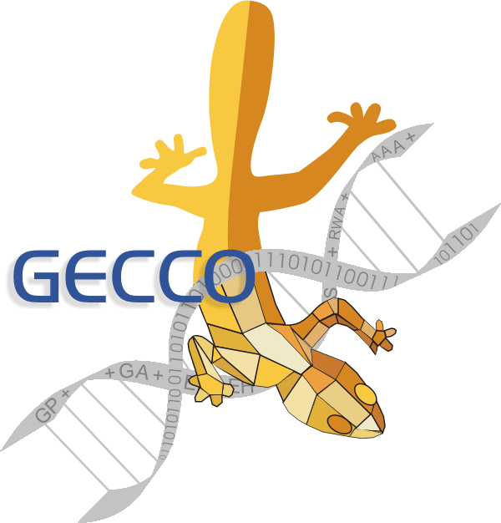
Genetic and Evolutionary Computation Conference (GECCO-2002)

All registrants receive five printed volumes: Conference Proceedings, Tutorial Notes, Workshops, Late-Breaking Papers, and Proceedings of the Evolutionary Computing in Industry track; admission to all workshops on Tuesday July 9; admission to a tutorial in each of the four timeslots on Wednesday July 10; all technical sessions Thursday-Saturday July 11-13; free refreshments; and one admission each to the opening reception on July 10 and to the poster reception on Friday July 12.

You can also join now the International Society for Genetic and Evolutionary Computation, which entitles you to substantial savings on the registration fee and free subscriptions to two journals: Evolutionary Computation and Genetic Programming and Evolvable Machines. The journal subscriptions are effective January 1, 2003. If you already subscribe to these journals, your subscription will be renewed for 2003 with your membership fees. Note that you can join ISGEC without attending GECCO.

Please complete the two pages of this form and fax to 1-650-321-4457 (if paying by credit card) or mail to:
GECCO-2002 c/o American Association for Artificial Intelligence
445 Burgess Drive, Menlo Park, CA 94025 USA

Personal Information
Name:
Affiliation:
Address:
City: State/Prov.: Post/Zip Code: Country:
Daytime Phone: E-mail Address:

Registration Options

ISGEC Membership
 | Cost (US Dollars) | Is this a renewal? (yes/no)
Regular | $120
Student (with valid ID) | $50

GECCO Registration
ISGEC or AAAI Members | Early (on or before April 5) | Regular (April 6- June 10) | Late (June 11 or later)
Regular | $680 | $720 | $760
Academic, govt., or non-profit | $480 | $520 | $560
Student | $255 | $295 | $315

Non-members
Regular | $780 | $820 | $860
Academic, govt., or non-profit | $580 | $620 | $660
Student | $295 | $335 | $355
You can pay the member rates by joining ISGEC now. You then receive two journals for one year for a total added cost of only $20 ($10 for students). Students must send legible proof of student status. A limited number of student travel grants are available – to apply, see the GECCO web pages (www.isgec.org/GECCO-2002).

Amount of payment US$

 Check or money order payable to "AAAI" in US funds  Mastercard  Visa  American Express
Credit Card Number
Expiration Date Name on Card Signature

No refunds will be made, but we will transfer your registration to a person you designate upon notification.

Workshops. Tuesday July 9, 2002
All GECCO registrants will receive the workshops book, containing material supplied by participants of ALL workshops.
Check off which workshops you wish to attend.

Full Day Workshops
Graduate Student Workshop
Evolutionary Computation and Multi-Agent Systems (ECOMAS 2002)
Morning Workshops (8:30 AM – 12:30PM)
Approximation and Learning in Evolutionary Computation
Evolutionary Computation for Optimization in Industry
Grammatical Evolution Workshop (GEWS 2002)
Intelligent Interface and Interacting Agents Through Evolutionary Computation
ISGEC Workshop on Standards
Toward Interactive Evolutionary Search and Exploration Systems
Afternoon Workshops (2:00 AM – 6:00PM)
Biological Applications of Evolutionary Computation
Learning and Adaptation in Evolutionary Computation
Representations for Genetic and Evolutionary Algorithms
Scheduling: Bringing Together Theory and Practice
Understanding Coevolution: Theory and Analysis of Coevolutionary Algorithms

Tutorials. Wednesday July 10, 2002
All GECCO registrants will receive the tutorials book, containing notes supplied by instructors of ALL tutorials.
Check one tutorial to attend from each of the four timeslots.

8:30 AM – 10:15 AM
Design of Competent GAs: Toward a Computational Theory of Innovation, David E. Goldberg
Evolution of Sensors, D.Polani, T.Uthmann
Genetic Programming Theory I, W. Langdon, R. Poli
Genetics 101, Annie Wu
Introduction to Evolution Strategies, Ingo Rechenberg
Introduction to Genetic Algorithms, Robert Heckendorn
Modeling Real and Artificial Financial Markets, Sonia Schulenburg
Quantum Computing for GP, Lee Spector

10:35 AM – 12:20 PM
Beyond "No Free Lunch" Theorem, Darrell Whitley
Making GAs work in the real world: Guidelines from competent GA theory, B. Minsker, P. Reed
Evolution of Engineered Structures, D.Grierson, P. Hajela Canceled
GEC in Hydroinformatics, Vladan Babovic Canceled
Genetic Programming Theory II, W. Langdon, R. Poli
Introduction to Classifier Systems, W. Stoltzmann, PL Lanzi
Introduction to Genetic Programming, John Koza
Parallel Genetic Algorithms, Erick Cantú-Paz

1:50 PM – 3:35 PM
Bionics: Building on Bio-Evolution, Ingo Rechenberg
Creative Evolutionary Systems, Peter Bentley
Evolutionary Robotics, A. Schultz, M. Potter
Evolving Competitive Games, David Fogel Canceled
Genetic Algorithms Theory, Jonathan Rowe
Grammatical Evolution, C. Ryan, M. O'Neill
Multiobjective Genetic Algorithms, Carlos Coello
Probabilistic Model Building GAs, Martin Pelikan

3:55 PM – 5:40 PM
Ant Colony Optimization, Martin Middendorf
Evolvable Hardware, Tetsuya Higuchi
Evolutionary Scheduling and Routing, Peter Ross
Immune System Computing, Dipankar Dasgupta
Introduction to Adaptive Geno-Fuzzy Systems, Charles Karr
Software Testing via EC, J. Wegener, M. Harman
Unified Overview of Evolutionary Computation, Kenneth De Jong
Visualization in Evolutionary Computation, Christian Jacob

